**Experiment - 4**

**Date of Performance: 12/05/2022 Date of Submission:**

**DIV: A** **Batch: A4**

**Team Members:**

**Name: SAP ID:**Dhruvi Jodhawat 60004190032

Harvy Gandhi 60004190043

Junaid Girkar 60004190057

**Aim**: Develop Activity diagram and DFD (up to 2 levels) for the project.

**Theory**:

**Activity Diagram**:

A UML activity diagram depicts the dynamic behavior of a system or part of a system through the flow of control between actions that the system performs. It is similar to a flowchart except that an activity diagram can show concurrent flows. The main component of an activity diagram is an action node, represented by a rounded rectangle, which corresponds to a task performed by the software system. Arrows from one action node to another indicate the flow of control. That is, an arrow between two action nodes means that after the first action is complete the second action begins. A solid black dot forms the initial node that indicates the starting point of the activity. A black dot surrounded by a black circle is the final node indicating the end of the activity. A fork represents the separation of activities into two or more concurrent activities. It is drawn as a horizontal black bar with one arrow pointing to it and two or more arrows pointing out from it. Each outgoing arrow represents a flow of control that can be executed concurrently with the flows corresponding to the other outgoing arrows. These concurrent activities can be performed on a computer using different threads or even using different computers

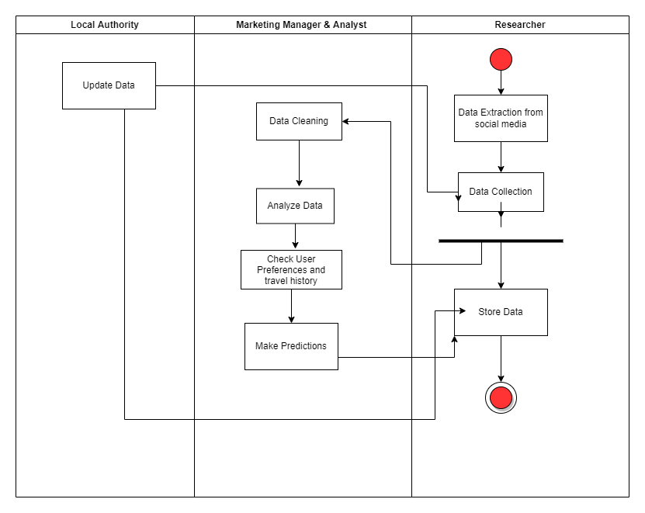

**Data Flow Diagrams**:

The data flow diagram enables you to develop models of the information domain and functional domain. As the DFD is refined into greater levels of detail, you perform an implicit functional decomposition of the system. At the same time, the DFD refinement results in a corresponding refinement of data as it moves through the processes that embody the application.

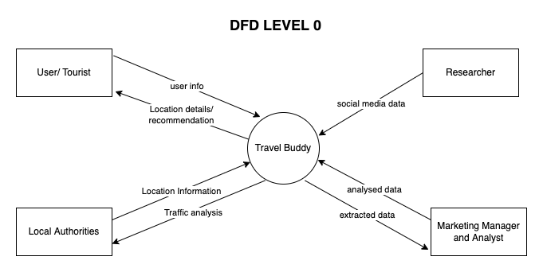

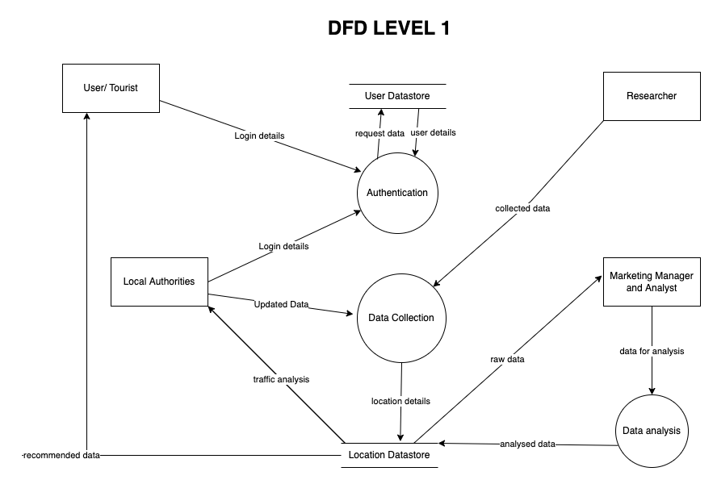

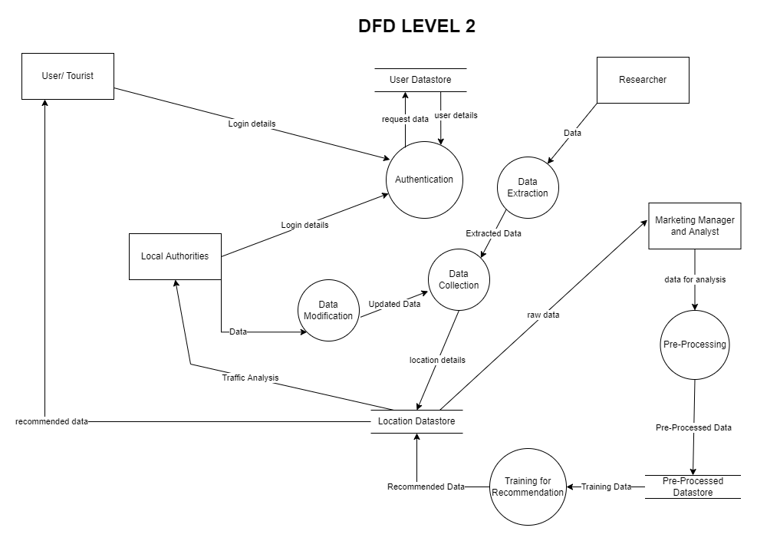

**Conclusion**:

Thus, we are able to draw a Swim lane diagram for our case study. We are also able to depict the flow of data through various processes through different level DFDs.